Sjekkliste: ARB-805507
Revisjon: | 05 (Omega 8)
Godkjent: | 06.05.2026
Godkjent av: | Hege Magnussen
Navn: | SA-M17-611: Update Bane NOR’s RAMS Deliverables

Prosedyre:

Category Task | Description
Task-ID | SA-M17-611
Event that triggers the task | Update Bane NORs RAMS Deliverables is a continual task.  In addition, this task should handle the following sudden events*:  - a planned engineering is not in line with current regulation/requirements.  - a scope change (e.g., simultaneous train movement on station)  - a change in prerequisites  - If a change in prerequisites requires a change in the Generic Application (GA), the change should be handled within the framework of the GA acceptance instruction (STY 605477)  - a change in regulations that affect the project deliveries  - a proposed changes in system design that might affect previous activities that entail changes or additions to the analyses already planned (e.g., remove a point at a station)  - Bane NOR becomes aware of an undocumented hazard  - an acknowledgement of a need for a document review or other communication with Independent Safety Assessor (ISA), Assessment Body (AsBo) or Notified Body (NoBo)  * A Sudden event is the occurrence of a circumstance or acknowledgement of something that requires a non-trivial response from Bane NOR.
Task symbol in activity | 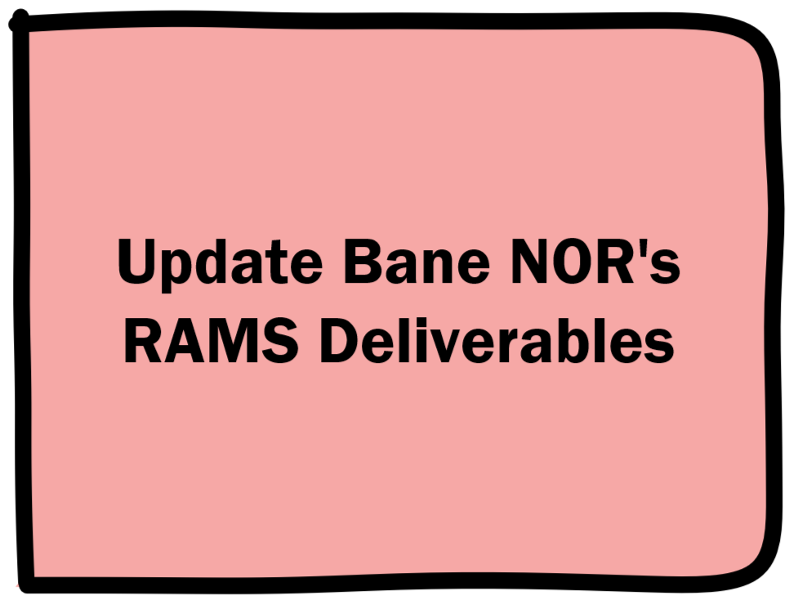
Task purpose | Ensure compliance with the RAMS standards EN 50126 and EN 50129, and provide evidence that the system built is reliable, available, maintainable, and safe.
Input | For input documents for this task see ‘Sjekkliste for dokumentplan ERTMS-Signalling SA, byggeplan og produksjon’ (ARB-805371), filter for Task-ID SA-M17-611.
Resources needed to handle task | See ‘Sjekkliste for dokumentplan ERTMS-Signalling SA, byggeplan og produksjon’ (ARB-805371) for description of the required competence, filter for Task-ID SA-M17-611.
Work | - Update the RAMS plan  - Update the Hazard and RAM log  - Update the SASC (SA- Safety Case)  - Consider the need to update the safety-related application conditions (SRAC)  - Consider the need for an impact analysis for sudden events.  - Consider the need to return to RAMS phase for changes affecting system requirement, see SA-M17-520: Bane NOR Adjusts Design input after A3 milestone  - Provide proof of work done in this task (e.g., a document report from ProArc, a list of relevant documents found in Saksrom or other relevant information about the work)  The work listed above may or may not be related to deliverables from Siemens.
Relevant documents for this task (governing, guiding, supporting or information) | - EN 50126: Railway Applications – The Specification and Demonstration of Reliability, Availability, Maintainability and Safety (RAMS)  - EN 50129: Railway Applications – Communication, Signalling and Processing Systems – Safety Related Electronic Systems for Signalling  - SIG general RAMS plan signalling (1000005562)  - Program level RAMS plan (1000000424)  - Process requirements  - Felles mal for avvikslogg (ARB-802591)  - Instruks for bruk av felles mal for avvikslogg signal (ARB-802590)  - ERTMS - Signalling SA - Construction plan process, Proof of work - template (ARB-805518)
Output | - Documents from input with updated status as described in ‘Sjekkliste for dokumentplan ERTMS-Signalling SA, byggeplan og produksjon’ (ARB-805371), filter for Task-ID SA-M17-611  - Any new documents made in this task, see output only in ‘Sjekkliste for dokumentplan ERTMS-Signalling SA, byggeplan og produksjon’ (ARB-805371), filter for Task-ID SA-M17-611
General business rules for the task | N/A
Spin-off task | SA-M17-520: Bane NOR Adjusts Design input after A3 milestone (if needed)
Quality control | - Check that the documents are archived with the correct codes for proof of work purposes. See "How to create a document report from ProArc" (ARB-805520)  - Check that the involved recourses fulfil the competence requirements described in "Sjekkliste for dokumentplan ERTMS-Signalling SA, byggeplan og produksjon" (ARB-805371)  - Archive the proof of work report
Task completion | The task may only be considered complete if all the following are true:  - All the documents from input have been accepted as fit for purpose, see "Sjekkliste for dokumentplan ERTMS-Signalling SA, byggeplan og produksjon’ (ARB-805371)”  - Any new documents made in this task, see output only in ‘Sjekkliste for dokumentplan ERTMS-Signalling SA, byggeplan og produksjon’ (ARB-805371) have the appropriate status  - The quality control has been completed  - The proof of work has been archived
Meld inn forslag til forbedringer til e-post adresse: felles.ertms-sty@banenor.no

Sjekkpunkter:

Element | Beskrivelse | Kommentarer
000 | Check ‘checked’ to lock the checklist so that it does not update with new master data. This only applies if Omega 365 is used.  ☐ Sjekket ☐ N/A
001 | This task has been completed.  ☐ Sjekket ☐ N/A
002 | Work
002,01 | Update the RAMS plan  ☐ Sjekket ☐ N/A
002,02 | Update the Hazard and RAM log.  ☐ Sjekket ☐ N/A
002,03 | Update the SASC (SA- Safety Case).  ☐ Sjekket ☐ N/A
002,04 | Consider the need to update the safety-related application conditions (SRAC).  ☐ Sjekket ☐ N/A
002,05 | Consider the need for an impact analysis for sudden events.  ☐ Sjekket ☐ N/A
002,06 | Consider the need to return to RAMS phase for changes affecting system requirement, see SA-M17-520: Bane NOR Adjusts Design input after A3 milestone  ☐ Sjekket ☐ N/A
002,08 | Provide proof of work done in this task (e.g., a document report from ProArc, a list of relevant documents found in Saksrom or other relevant information about the work)  ☐ Sjekket ☐ N/A
003 | Quality control
003,01 | Check that the documents are archived with the required status found in the ‘Sjekkliste for dokumentplan ERTMS-Signalling SA, byggeplan og produksjon’ (ARB-805371) for proof of work purposes.  - See "How to create a document report from ProArc" (ARB-805520)  Check that the resources involved fulfil the competence requirements described in "Sjekkliste for dokumentplan ERTMS-Signalling SA, byggeplan og produksjon" (ARB-805371)  Archive proof of work report.  ☐ Sjekket ☐ N/A

Roller & Ansvarlige:

Sekv. | Beskrivelse (Rolle, Ekspertise, Ansv.kode, Skal signere)
1 | Role: RAMS - Endringstilgang - ENT/BN  Ekspertise: P3 - ANALYSER  Ekspertise nivå: 1  Utførende  Ansvarlig: Utførende
1 | Role: RAMS - Endringstilgang - ENT/BN  Ekspertise: P7 - SIKKERHETSBEVIS  Ekspertise nivå: 1  Utførende  Ansvarlig: Utførende
1 | Role: RAMS - Endringstilgang - ENT/BN  Ekspertise: P3 - ANALYSER  Ekspertise nivå: 1  Kontrollør  Ansvarlig: Kontrollør
1 | Role: RAMS - Endringstilgang - ENT/BN  Ekspertise: P7 - SIKKERHETSBEVIS  Ekspertise nivå: 1  Kontrollør  Ansvarlig: Kontrollør
1 | Role: Signal - Prosjekteringsleder - ENT/BN  Ekspertise: PL1 - PROSJEKTERINGSLEDELSE  Ekspertise nivå: 1  Utførende  Ansvarlig: Utførende  Skal signere
1 | Role: Signal - Prosjekteringsleder - ENT/BN  Ekspertise: PL1 - PROSJEKTERINGSLEDELSE  Ekspertise nivå: 1  Kontrollør  Ansvarlig: Kontrollør

