Sjekkliste: ARB-805510
Revisjon: | 05 (Omega 8)
Godkjent: | 06.05.2026
Godkjent av: | Hege Magnussen
Navn: | SA-M17-522: Verify RAMS Life Cycle Phase 5

Prosedyre:

Category: Task | Description
Task-ID | SA-M17-522
Event that triggers the task | Bane NOR has established Bane NOR's RAMS deliverables and Bane NOR  has adjusted design input after A3 Milestone (if it was needed)
Task symbol in activity | 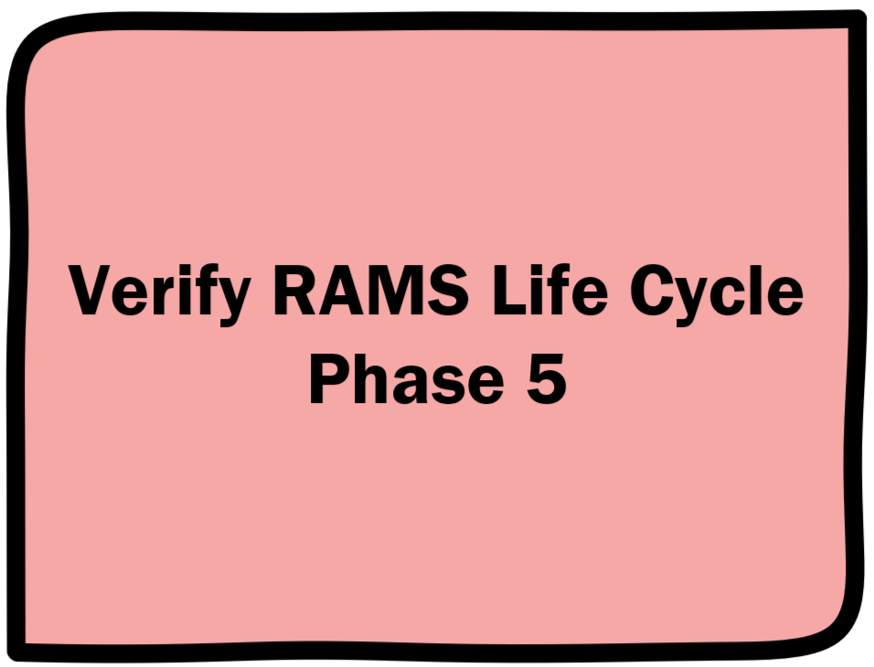
Task purpose | The objective of verification is to demonstrate that the requirements of RAMS life cycle phase 5 have been fulfilled.
Input | For input documents for this task see ‘Sjekkliste for dokumentplan ERTMS-Signalling SA, byggeplan og produksjon’ (ARB-805371), filter for Task-ID SA-M17-522.
Resources needed to handle task | See ‘Sjekkliste for dokumentplan ERTMS-Signalling SA, byggeplan og produksjon’ (ARB-805371) for description of the required competence, filter for Task-ID SA-M17-522.  The verifier must not be involved in other activities in the same life-cycle phase*.  *See EN 50126-2:2017 (E), Clause 7.3)
Work | Verify activities  - Identify relevant activities that are to be verified as part of RAMS lifecycle phase 5. Find description in EN50126-1 (RAMS) Clause 7.6 Phase 5: Architecture and apportionment of system requirements.  - Verify activities completed in RAMS lifecycle phase 5. As a rule, Bane NOR shall verify the activities in Bane NOR's RAMS plan and the completion of the tasks related to RAMS life cycle phase 5.  Verify deliverables  RAMS (EN50126-1) require that the results of a life cycle phase shall be documented.  Verify the following deliverables:  - a) system architecture (structure of decomposition into subsystems etc.) including interface specifications and system hazard analysis (architecture and hazard analysis of subsystem and components);  - b) allocation of RAMS requirement specification to subsystems and/or components  - c) Acceptance Criteria and demonstration and acceptance processes and procedures;  - d) updated safety plan (if appropriate);  - e) updated RAM plan (if appropriate);  - f) updated RAM Validation Plan (if appropriate);  - g) updated Safety Validation Plan (if appropriate);  - h) updated Safety-Related Application Conditions (if appropriate);  - i) updated hazard log (if appropriate).  Provide proof of work done in this task (e.g., a document report from ProArc, a list of relevant documents found in Saksrom or other relevant information about the work)
Relevant documents for this task (governing, guiding, supporting or information) | - SIG general RAMS plan signalling (1000005562)  - Program level RAMS plan (1000000424)  - EN50126-1 (RAMS) Clause 7.6 Phase 5: Architecture and apportionment of system requirements.  - SA Safety Case from RAMS phase 1-4  - Process requirements  - Felles mal for avvikslogg (ARB-802591)  - Instruks for bruk av felles mal for avvikslogg signal (ARB-802590)  - Proof of work from previous activities in the ERTMS - Signalling SA - Construction plan process  - ERTMS - Signalling SA - Construction plan process, Proof of work - template (ARB-805518)
Output | - Documents from input with updated status as described in ‘Sjekkliste for dokumentplan ERTMS-Signalling SA, byggeplan og produksjon’ (ARB-805371), filter for Task-ID SA-M17-522  - Any new documents made in this task, see output only in ‘Sjekkliste for dokumentplan ERTMS-Signalling SA, byggeplan og produksjon’ (ARB-805371), filter for Task-ID SA-M17-522
General business rules for the task | N/A
Spin-off task | N/A
Quality control | Check that the documents are archived with the correct codes for proof of work purposes. See "How to create a document report from ProArc" (ARB-805520).  Check that the involved recourses fulfil the competence requirements described in "Sjekkliste for dokumentplan ERTMS-Signalling SA, byggeplan og produksjon" (ARB-805371).  Archive the proof of work report.
Task completion | The task may only be considered complete if all the following are true:  - All the documents from input have been accepted as fit for purpose, see "Sjekkliste for dokumentplan ERTMS-Signalling SA, byggeplan og produksjon’ (ARB-805371)”  - Any new documents made in this task, see output only in ‘Sjekkliste for dokumentplan ERTMS-Signalling SA, byggeplan og produksjon’ (ARB-805371) have the appropriate status  - The quality control has been completed  - The proof of work has been archived
Meld inn forslag til forbedringer til e-post adresse: felles.ertms-sty@banenor.no

Sjekkpunkter:

Element | Beskrivelse | Kommentarer
000 | Check ‘checked’ to lock the checklist so that it does not update with new master data. This only applies if Omega 365 is used.  ☐ Sjekket ☐ N/A
001 | This task has been completed.  ☐ Sjekket ☐ N/A
002 | Work
002,01 | Verify activities
002,01,01 | Identify relevant activities that are to be verified as part of RAMS lifecycle phase 5. Find description in EN50126-1 (RAMS) Clause 7.6 Phase 5: Architecture and apportionment of system requirements.  ☐ Sjekket ☐ N/A
002,01,02 | Verify activities completed in RAMS lifecycle phase 5. As a rule, Bane NOR shall verify the activities in Bane NOR's RAMS plan and the completion of the tasks related to RAMS life cycle phase 5.  ☐ Sjekket ☐ N/A
002,02 | Verify deliverables  RAMS (EN50126-1) require that the results of a life cycle phase shall be documented.  Verify the following deliverables:
002,02,01 | a) system architecture (structure of decomposition into subsystems etc.) including interface specifications and system hazard analysis (architecture and hazard analysis of subsystem and components);  ☐ Sjekket ☐ N/A
002,02,02 | b) allocation of RAMS requirement specification to subsystems and/or components;  ☐ Sjekket ☐ N/A
002,02,03 | c) Acceptance Criteria and demonstration and acceptance processes and procedures;  ☐ Sjekket ☐ N/A
002,02,04 | d) updated safety plan (if appropriate);  ☐ Sjekket ☐ N/A
002,02,05 | e) updated RAM plan (if appropriate);  ☐ Sjekket ☐ N/A
002,02,06 | f) updated RAM Validation Plan (if appropriate);  ☐ Sjekket ☐ N/A
002,02,07 | g) updated Safety Validation Plan (if appropriate);  ☐ Sjekket ☐ N/A
002,02,08 | h) updated Safety-Related Application Conditions (if appropriate);  ☐ Sjekket ☐ N/A
002,02,09 | i) updated hazard log (if appropriate).  ☐ Sjekket ☐ N/A
002,03 | Provide proof of work
002,03,01 | Provide proof of work done in this task (e.g., a document report from ProArc, a list of relevant documents found in Saksrom or other relevant information about the work)  ☐ Sjekket ☐ N/A
003 | Quality control
003,01 | Check that the documents are archived with the required status found in the ‘Sjekkliste for dokumentplan ERTMS-Signalling SA, byggeplan og produksjon’ (ARB-805371) for proof of work purposes.  - See "How to create a document report from ProArc" (ARB-805520)  Check that the involved recourses fulfil the competence requirements described in "Sjekkliste for dokumentplan ERTMS-Signalling SA, byggeplan og produksjon" (ARB-805371)  Archive the proof of work report  ☐ Sjekket ☐ N/A

Roller & Ansvarlige:

Sekv. | Beskrivelse (Rolle, Ekspertise, Ansv.kode, Skal signere)
1 | Role: Signal - Prosjekteringsleder - ENT/BN  Ekspertise: PL1 - PROSJEKTERINGSLEDELSE  Ekspertise nivå: 1  Utførende  Ansvarlig: Utførende  Skal signere
1 | Role: Signal - Prosjekteringsleder - ENT/BN  Ekspertise: PL1 - PROSJEKTERINGSLEDELSE  Ekspertise nivå: 1  Kontrollør  Ansvarlig: Kontrollør
1 | Role: Signal - Validator - BN  Ekspertise: V&V - VERIFISERING&VALIDERING  Ekspertise nivå: 1  Utførende  Ansvarlig: Utførende
1 | Role: Signal - Validator - BN  Ekspertise: V&V - VERIFISERING&VALIDERING  Ekspertise nivå: 1  Kontrollør  Ansvarlig: Kontrollør

