Best Practice for the task “SA-M17-613: Agree on Documents to be Sent to CAB Evaluation”
- Purpose and Scope
The purpose of this document is to provide a guide for the work in SA-M17-613: Agree on Documents to be Sent to CAB Evaluation on matters such as who should be involved and what documents would normally be sent to the CAB Evaluation (a later task).
This guideline applies to the ERTMS SA process and describes best practice for the task “SA-M17-613: Agree on Documents to be Sent to CAB Evaluation».
- Description
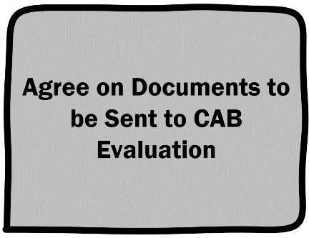
This description is based on text from IKT, and the text uses ITIL vocabulary. Within the ITIL framework,
this task is known as “Pre-Cab”. As a non-ITIL reader, you should understand any reference to “pre-CAB” as a reference to this task.
Carry out pre-CAB (as described below)
The following persons shall participate in the pre-CAB:
  - Project manager
  - Engineering manager
  - Configuration manager (responsible for version management of HW, SW and documentation)
  - RAMS and quality advisors
  - 2. line system support for KvIKT in Drift og teknologi.
Identify which of the documents listed below shall be submitted to CAB in activity “Perform CAB Evaluation" (Task and TASK ID not ready. Use “SAP911 Perform CAB” until new description is ready)
Typical input documents to CAB are listed below, make appropriate changes. Complete list should be documented in the pre-CAB memo.
  - Specific application design and engineering documentation (Doc_B4)
  - System architecture/network structure for line/area (Doc_C3)
  - Detailed engineering documentation (Doc_C4)
  - System component/configuration item information (Doc_C5)
  - Configuration data (Doc_C6-01)
  - Release document (Doc_C6-02) and HW/SW delivered (Doc_C6-02)
  - List of instruments and special tools, line specific (Doc_D1-04)
  - Spare parts list (Doc_D1-08)
  - Specific RAM and Safety documentation (Doc_F3, Doc_F5)
  - Specific Migration RAM and Safety documentation (Doc_F6, Doc_F7)
  - Training documentation (Doc_H2-01/H3-01) and evidence of completed training for relevant personnel
  - Plans for integration with technical support systems
  - Detailed schedule for commissioning with detailed activities and distribution of responsibility (Doc_C3-09)
  - Information and communication plans (warning plans)
  - Rollback plans
  - Generic application staging test report (Doc_E4-06)
  - Plans for access control
  - Reports and deviation logs from RAMS implementation revision and phase verification
  - Reports and deviation logs from GFB
  - Report from ATTL
These documents may sometimes be reused or alternatively developed from earlier projects using the same system:
  - Description of system ownership, system management responsibility and maintenance responsibilities
  - Generic working instructions in BaneData (Doc_A2-01/02, Doc_A3-01/02)
  - Generic OAM documentation
  - Plans for spare parts storage and logistical support (Doc_D1-09/10)
  - Defined KPIs for operational phase
  - Risk and vulnerability analysis for the system
Create memo from pre-CAB. The memo shall describe which documents are to be presented to CAB and provide arguments for any decision not to put forward documents normally included.

- Revision history
Rev nr | Date | Change in revision
000 | 17.04.2024 | Etablert første gang

